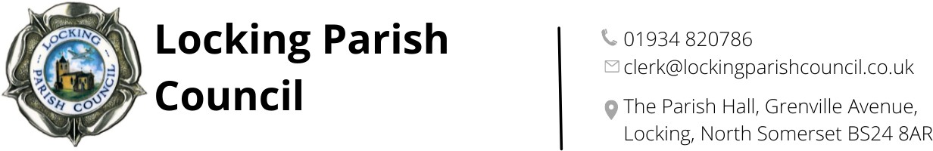

Minutes of a meeting of Locking Parish Council’s Finance and Human Resources Committee
held on Thursday 19 March 2026 at Locking Parish Hall at 7.30pm

Meeting opened at: 7:30pm Meeting closed at: 7:50pm

Present: Cllr C Prosser, Cllr W Ashdown, Cllr P Jones, Cllr M Tremlett, Cllr W Bearsby, Cllr P Schofield

Also present: Clerk’s Assistant and one member of the public

PUBLIC PARTICIPATION

To receive and hear any person who wishes to address the Committee – None received

MATTERS FOR DECISION

FHR37 To receive apologies for absence and to approve reasons where appropriate.
Cllr J Smith - APPROVED
Cllr I Hilder – APPROVED
Cllr K Shepherd - APPROVED
FHR38 To receive Declarations of Interest by PCllrs and to consider any written applications for dispensations. None received
FHR39 To receive and confirm the Minutes of the Finance & Human Resources Committee meeting held on 18 December 2025.
RESOLVED: That the minutes of the Finance & Human Resources Committee meeting held on 18 December 2025 (previously circulated), be taken as read, agreed as being true and correct record and as a consequence, signed by the chairman of the meeting. AGREED.
FHR40 Internal Financial Control Quarter 3 report from Cllr W Bearsby.
It is a requirement that the Parish Council ensures that its financial management is adequate and effective and that the Parish Council has a sound system of internal control which facilities the effective exercise of their functions and which includes arrangements for the management of risks as per Locking Parish Council Financial Regulations 2.6.
Cllr Bearsby confirmed that he had conducted a robust review of the Internal Financial Controls for the third quarter of this financial year and was pleased to advise that as per his report everything was in good order. Members thanked Cllr Bearsby for carrying out the review.
FHR41 Quarterly review of the following budgets and reserves as of 28 February 2026
Budgets:
- General Account - NOTED
- Assets & Amenities Committee - NOTED
- Community Support Fund - NOTED
- Locking Community Events - NOTED
- OBR car park - NOTED
- Old Banwell Road Car Park - Electric Gates – NOTED and AGREED to begin getting quotes in April 2026

Reserves:
- General Account - NOTED

Items for next Agenda: Analysis of this year’s budget and prepare for next year’s budget
There being no further business the meeting chairman closed the meeting at 7:50pm

Signed (Chair) ………………………………………………….. Date: ………………………………

The next meeting of Locking Parish Council’s Finance & Human Resources Committee 21st May at 7:30pm.
Members are reminded that the Council has a general duty to consider the following matters in the exercise of any of its functions: Equal Opportunities (race, gender, sexual orientation, marital status and any disability)
Crime & Disorder, Health & Safety and Human Rights.

