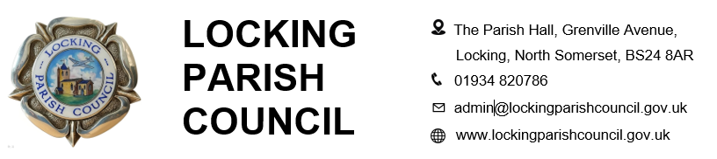

Members of the Public and Press are entitled to be at the following meeting in accordance with the Public Bodies (Admission to Meetings) Act 1960 section 1 extended by Local Government Act 1972 section 100 unless precluded by the Parish Council by resolution during the whole or part of the proceedings. Such entitlement does not however include the right to speak on any matter except at the commencement of the meeting given over specifically for that purpose and providing that prior notice has been given to the Parish Clerk by 12noon on the Tuesday preceding the meeting.
To: All members of Locking Parish Council:

Dear Councillors
The Meeting of Locking Parish Council’s Assets and Amenities Committee, will be held on Thursday 15 October 2026 in the Nurse Thomas Suite, Locking Parish Hall commencing at 7pm to which you are summoned to attend. The following business is to be transacted.
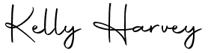
Kelly Harvey
Clerk/RFO
7 October 2026
PUBLIC PARTICIPATION

To receive and hear any person who wishes to address the Council, upon prior notice being received (The Chairman will select the order of the matters to be heard, each speaker will be limited to a period of 3 minutes (to a maximum of 15 minutes total public participation at the Chairman’s discretion.

AGENDA

To receive apologies for absence and to approve reasons where appropriate.
To receive declarations of interest by councillors and to consider any written applications for dispensations

Minutes:
To receive and confirm the minutes of the Assets & Amenities Committee meeting held on 16 July 2026
Finances:
- To retrospectively receive payments and receipts for Assets & Amenities Committee from 11 July to 12 October 2026
- To receive the budgetary control report for 1 April – 30 September 2026

To consider a resident's request for pedestrian access to the park via Council-owned land

To consider a proposal from Weston Ability Football Club with regards to the use of the playing fields

To consider a request for a public seat at the junction of Byron Road and Elm Tree Road

Incident reports

Clerk’s Report, Correspondence & Items for next Agenda:
(Please note that the Council is unable to make any formal decisions under this item).
To receive the Clerk’s report, note any correspondence received since the last meeting that is not an item on the agenda and note items for the next Agenda

The next meeting of Locking Parish Council’s Assets and Amenities Committee will be at 7:00pm on the 5 Nov 2026.
Members are reminded that the Council has a general duty to consider the following matters in the exercise of any of its functions: Equal Opportunities (race, gender, sexual orientation, marital status and any disability) Crime & Disorder, Health & Safety and Human Rights.

