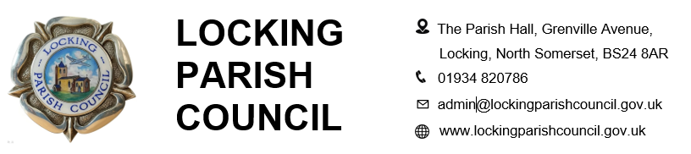

Members of the Public and Press are entitled to be at the following meeting in accordance with the Public Bodies (Admission to Meetings) Act 1960 section 1 extended by Local Government Act 1972 section 100 unless precluded by the Parish Council by resolution during the whole or part of the proceedings. Such entitlement does not however include the right to speak on any matter except at the commencement of the meeting given over specifically for that purpose and providing that prior notice has been given to the Parish Clerk by 12noon on the Tuesday preceding the meeting.

To: All members of Locking Parish Council:

Dear Councillors

You are summoned to a meeting of Locking Parish Council to be held in the Nurse Thomas Suite, Locking Parish Hall, Grenville Avenue, Locking on Thursday 1 October 2026 commencing at 7pm when the following business will be transacted.

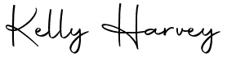
Kelly Harvey
Clerk/Responsible Financial Officer
24 September 2026

CO-OPTION MEETING TO COMMENCE AT 7PM

Having regard to the confidential nature of the business to be transacted, the Co-option meeting is now not open to the Press and Public pursuant to Section 1 of the Public Bodies (Admission to Meetings) Act 1960

- Chair to open the Co-option meeting
- To receive apologies for absence and to approve reasons where appropriate
- Co-option of new councillor(s)
- Signing of the Declaration of Office and Consent Form
- Completion of Register of Members Interest Form
- Chair to close the Co-option meeting

FULL COUNCIL MEETING TO COMMENCE AT 7.30PM

The meeting will be open to the press and members of the public

AGENDA

PUBLIC PARTICIPATION - To receive and hear any person who wishes to address the Council, upon prior notice being received (The Chairman will select the order of the matters to be heard, each speaker will be limited to a period of 3 minutes (to a maximum of 15 minutes total public participation at the Chairman’s discretion)

Regular Reports - To receive and note the following regular reports:
  - District Councillor Report
  - Neighbourhood Police Report
  - Campaign to Protect Rural England (CPRE)
  - Locking Parklands Stakeholders
MATTERS FOR DECISION
To receive apologies for absence and to approve reasons where appropriate.

To receive declarations of interest by councillors and to consider any written applications for dispensations.

Minutes:
- To receive and confirm the minutes of the council meeting held on 3 Sept 2026
- To receive and confirm the minutes of the council meeting held on 22 Sept 2026

Finances:
  - To retrospectively approve monthly receipts and payments for Aug 2026
  - To note the bank reconciliation and Unity Trust bank statements for Aug 2026
  - To review expenditure against budgets from 1 April to 31 Aug 2026
  - To note the Conclusion of the review of the Annual Governance and Accountability Return (AGAR) for the year ended 31 March 2026, with minor scope of improvement.
Chair’s report
Planning (applications can be viewed via North Somerset Council Planning Applications website)
- 26/P/1739/AOC Phase 8 And 10 Locking Parklands, Locking Moor Road - Request to Discharge Condition 8 (Car Parking Management Plan) on application 24/P/1818/RM
- 26/P/1686/AOC Locking Parklands, Locking Moor Road - Request to partially discharge conditions 7 (Construction Programme) and 8 (Site Development Plan) on application 13/P/0997/OT2 relating to Phases 8 and 10 only.
- 26/P/1839/FUH 15 The Orchard, Locking - Proposed erection of a two-storey side extension and a single-storey rear extension
To receive an update on the electric gates project

To review hall hire charges for regular hirers for 2027-28

To review football pitch hire charges for 2027-28

Incident report forms

Clerk’s report, correspondence and items for next agenda: (Please note that the Council is unable to make any formal decisions under this item). To receive the Clerk’s report, note any correspondence received since the last meeting that is not an item on the agenda and note items for the next Agenda.

PART 2
Exclusion of press and public. (The Council is recommended to resolve that members of the press and public be excluded from the meeting during consideration of the agenda item/s below by reason of the confidential nature of the item/s of business to be transacted, in accordance with section 1 (2) of the Public Bodies (Admission to Meetings) Act 1960.
To receive and consider the Staff Working Group recommendation following the probationary review of the Clerk

The next meeting of Locking Parish Council 5 November 2026

Members are reminded that the Council has a general duty to consider the following matters in the exercise of any of its functions:
Equal Opportunities (race, gender, sexual orientation, marital status and any disability) Crime & Disorder, Health & Safety and Human Rights.

