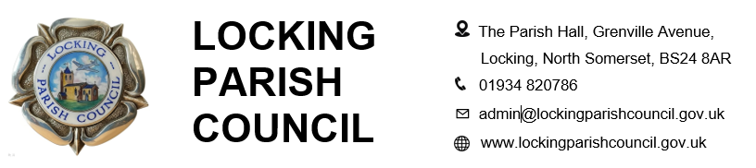

Members of the Public and Press are entitled to be at the following meeting in accordance with the Public Bodies (Admission to Meetings) Act 1960 section 1 extended by Local Government Act 1972 section 100 unless precluded by the Parish Council by resolution during the whole or part of the proceedings. Such entitlement does not however include the right to speak on any matter except at the commencement of the meeting given over specifically for that purpose and providing that prior notice has been given to the Parish Clerk by 12noon on the Tuesday preceding the meeting.

To: All members of Locking Parish Council:

Dear Councillors

You are summoned to an Extra Ordinary Full Council meeting of Locking Parish Council to be held in the Nurse Thomas Suite, Locking Parish Hall, Grenville Avenue, Locking on Tuesday 22 September 2026 commencing at 7pm when the following business will be transacted.

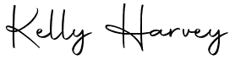
Kelly Harvey
Clerk/Responsible Financial Officer
16 September 2026

PUBLIC PARTCIPATION

To receive and hear any person who wishes to address the Council, upon prior notice being received (The Chairman will select the order of the matters to be heard; each speaker will be limited to a period of 3 minutes, to a maximum of 15 minutes total public participation at the Chairman’s discretion).

AGENDA

MATTERS FOR DECISION
To receive apologies for absence and to approve reasons where appropriate.

To receive declarations of interest by councillors and to consider any written applications for dispensations.

To receive and consider a quotation for the installation of CCTV at the car park

To receive and consider a quotation for the monitoring of CCTV at the car park

To receive and consider a quotation for internet installation at the car park

To consider the car park agreement with Locking Primary School
To discuss the Chair's role
PART 2
Exclusion of press and public. (The Council is recommended to resolve that members of the press and public be excluded from the meeting during consideration of the agenda item/s below by reason of the confidential nature of the item/s of business to be transacted, in accordance with section 1 (2) of the Public Bodies (Admission to Meetings) Act 1960.
To receive and consider the Clerk's recommendation following the probationary review of the Clerk's Assistant.

To consider and approve SLCC membership for the Clerk's Assistant and authorise the associated expenditure

To review and consider the revised job descriptions for the Parish Orderly and Parish Orderly Assistant

To implement the National Joint Council for Local Government Services (NJC) Pay Award 2026/27 and authorise payment of back pay to 1 April 2026

The next meeting of Locking Parish Council 1 October 2026

Members are reminded that the Council has a general duty to consider the following matters in the exercise of any of its functions:
Equal Opportunities (race, gender, sexual orientation, marital status and any disability) Crime & Disorder, Health & Safety and Human Rights.

