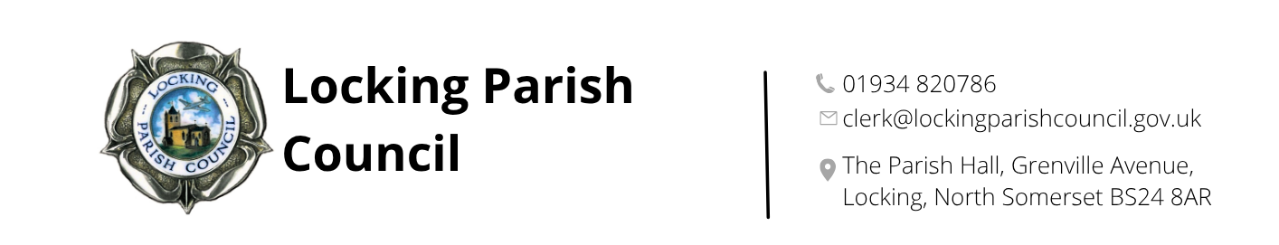

Members of the Public and Press are entitled to be at the following meeting in accordance with the Public Bodies (Admission to Meetings) Act 1960 section 1 extended by Local Government Act 1972 section 100 unless precluded by the Parish Council by resolution during the whole or part of the proceedings. Such entitlement does not however include the right to speak on any matter except at the commencement of the meeting given over specifically for that purpose and providing that prior notice has been given to the Parish Clerk by 12noon on the Tuesday preceding the meeting.

To: All members of Locking Parish Council:

Dear Councillors

You are summoned to a meeting of Locking Parish Council to be held in the Nurse Thomas Suite of Locking Parish Hall, Grenville Avenue, Locking on Tuesday 23rd June 2026 commencing at 7pm when the following business will be transacted.

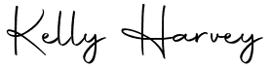
Kelly Harvey
Clerk/RFO
16 June 2026

PUBLIC PARTICIPATION

To receive and hear any person who wishes to address the Council, upon prior notice being received (The Chairman will select the order of the matters to be heard, each speaker will be limited to a period of 3 minutes (to a maximum of 15 minutes total public participation at the Chairman’s discretion).

AGENDA

To receive apologies for absence and to approve reasons where appropriate.

To receive declarations of interest by councillors and to consider any written applications for dispensations.

Finances:
- To consider and agree Section 1 - Annual Governance Statement 2025/26 (AGAR Page 4)
- To consider and approve Section 2 - Accounting Statements 2025/26, prepared on a receipt and payments basis (AGAR Page 5)
- To receive and review the Internal Auditor’s Report (AGAR Page 3)
- To receive and review the Explanation of Variances 2025/26
- To note the restatement of Year End figures for 2024/25 and explanation
- To receive and consider the detailed Internal Audit Report/Letter from Bridget Bowen following her visit on 5 June 2026
- To confirm that no conflicts of interest have been identified in respect of the External Auditor, BDO LLP
- To note the Notice of Public Rights and Publication of Unaudited Annual Governance & Accountability Return and the dates for the Exercise of Public Rights as 25 Jun to 5 Aug 2026
- To receive and approve payment for the Internal Audit completed by Bridget Bowen.

The next meeting of Locking Parish Council is 2 July 2026

Members are reminded that the Council has a general duty to consider the following matters in the exercise of any of its functions:
Equal Opportunities (race, gender, sexual orientation, marital status and any disability) Crime & Disorder, Health & Safety and Human Rights.

