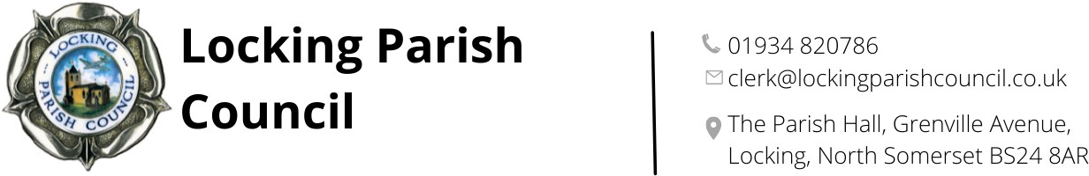
Members of the Public and Press are entitled to be at the following meeting in accordance with the Public Bodies (Admission to Meetings) Act 1960 section 1 extended by Local Government Act 1972 section 100 unless precluded by the Parish Council by resolution during the whole or part of the proceedings. Such entitlement does not however include the right to speak on any matter except at the commencement of the meeting given over specifically for that purpose and providing that prior notice has been given to the Parish Clerk by 12noon on the Tuesday preceding the meeting.
To: All members of Locking Parish Council:

Dear Councillors
The Meeting of Locking Parish Council’s Finance and Human Resources Committee, will be held on Thursday 21 May 2026 in the Nurse Thomas Suite, Locking Parish Hall commencing at 8.00pm to which you are summoned to attend. The following business to be transacted.

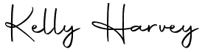
Kelly Harvey
Clerk/RFO
14 May 2026

PUBLIC PARTICIPATION

To receive and hear any person who wishes to address the Council, upon prior notice being received (The Chairman will select the order of the matters to be heard, each speaker will be limited to a period of 3 minutes (to a maximum of 15 minutes total public participation at the Chairman’s discretion).

AGENDA

To elect a chair

To elect a vice chair

To receive apologies for absence and to approve reasons where appropriate

To receive declarations of interest by councillors and to consider any written applications for dispensations

Minutes:
To receive and confirm the minutes of the Finance & Human Resources Committee meeting held on 19 March 2026

Internal Financial Control Q4 report from Cllr Bearsby

To appoint a member(s) to carry out the quarterly spot checks of financial controls for 2026-27
To confirm members for the Staff Working Group and set dates for performance management reviews of the Clerk and Clerk’s Assistant
Items for next agenda

The next meeting of Locking Parish Council’s Finance & Human Resources Committee 16 July 2026 at 8.00pm.
Members are reminded that the Council has a general duty to consider the following matters in the exercise of any of its functions: Equal Opportunities (race, gender, sexual orientation, marital status and any disability)
Crime & Disorder, Health & Safety and Human Rights.

