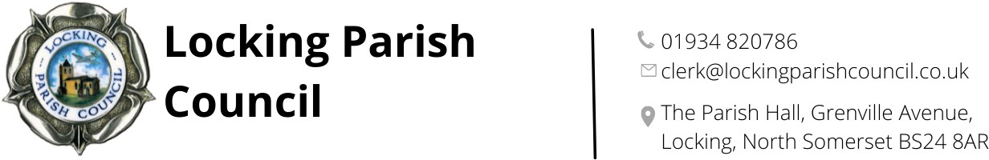
Members of the Public and Press are entitled to be at the following meeting in accordance with the Public Bodies (Admission to Meetings) Act 1960 section 1 extended by Local Government Act 1972 section 100 unless precluded by the Parish Council by resolution during the whole or part of the proceedings. Such entitlement does not however include the right to speak on any matter except at the commencement of the meeting given over specifically for that purpose and providing that prior notice has been given to the Parish Clerk by 12noon on the Tuesday preceding the meeting.
To: All members of Locking Parish Council:

Dear Councillors
The Meeting of Locking Parish Council’s Assets and Amenities Committee, will be held on Thursday 21 May 2026 in the Nurse Thomas Suite, Locking Parish Hall commencing at 7pm to which you are summoned to attend. The following business is to be transacted.
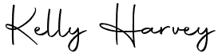
Kelly Harvey
Clerk/RFO
14 May 2026

PUBLIC PARTICIPATION

To receive and hear any person who wishes to address the Council, upon prior notice being received (The Chairman will select the order of the matters to be heard, each speaker will be limited to a period of 3 minutes (to a maximum of 15 minutes total public participation at the Chairman’s discretion.

AGENDA

To elect a chair

To elect a vice chair

To receive apologies for absence and to approve reasons where appropriate.
To receive declarations of interest by councillors and to consider any written applications for dispensations

Minutes:
To receive and confirm the minutes of the Assets & Amenities Committee meeting held on 16 April 2026
Finances:
- To retrospectively receive payments and receipts for Assets & Amenities Committee from 15 April to 14 May 2026
- To receive the budgetary control report for 1 April – 14 May 2026

To review rental agreement of The Triangle with 1st Hutton and Locking Scout Group

To agree the requirement for, and membership of the following working groups:
- Drainage swales, ditches and ponds
- OBR car park
- Community Orchard and Tiny Forest
- Football/Playing field
To confirm volunteers to complete the following:
- Annual risk assessments
- Annual asset register checks
- Weekly fire alarm check

Incident reports

Clerk’s Report, Correspondence & Items for next Agenda:
(Please note that the Council is unable to make any formal decisions under this item).
To receive the Clerk’s report, note any correspondence received since the last meeting that is not an item on the agenda and note items for the next Agenda

The next meeting of Locking Parish Council’s Assets and Amenities Committee will be at 7:30pm on the 16 July 2026.
Members are reminded that the Council has a general duty to consider the following matters in the exercise of any of its functions: Equal Opportunities (race, gender, sexual orientation, marital status and any disability) Crime & Disorder, Health & Safety and Human Rights.

