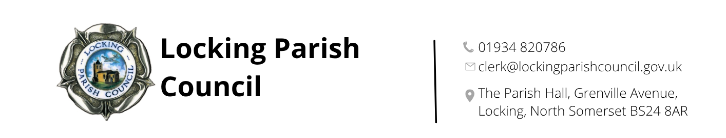

Members of the Public and Press are entitled to be at the following meeting in accordance with the Public Bodies (Admission to Meetings) Act 1960 section 1 extended by Local Government Act 1972 section 100 unless precluded by the Parish Council by resolution during the whole or part of the proceedings. Such entitlement does not however include the right to speak on any matter except at the commencement of the meeting given over specifically for that purpose and providing that prior notice has been given to the Parish Clerk by 12noon on the Tuesday preceding the meeting.

To: All members of Locking Parish Council:

Dear Councillors

You are summoned to the Annual Meeting of Locking Parish Council to be held in the Nurse Thomas Suite, Locking Parish Hall, Grenville Avenue, Locking on Thursday 7 May 2026 commencing at 7:30pm when the following business will be transacted.

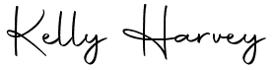
Kelly Harvey
Clerk
30 April 2026

PUBLIC PARTICIPATION

To receive and hear any person who wishes to address the Council, upon prior notice being received (The Chairman will select the order of the matters to be heard, each speaker will be limited to a period of 3 minutes (to a maximum of 15 minutes total public participation at the Chairman’s discretion).

- Unitary Cllr/Liaison Officer Report
- Police Report
AGENDA

- To elect a chair for the ensuing year: The Council must elect a chair to hold office until the next annual meeting of the parish council.

- To receive the chair’s declaration of acceptance of office or to permit him/her to make the declaration before or at the next meeting of the parish council.

- To elect a vice chair for the ensuing year: The council may appoint a vice chair to hold office until the next annual meeting of the parish council.

- To receive apologies for absence and to approve reasons where appropriate.

- To receive declarations of interest by councillor and to consider any written applications for dispensations.

- Minutes: To receive and confirm the minutes of the council meeting held on 9 April 2026

- Finances:
  - To retrospectively approve monthly receipts and payments from 1 to 30 April 2026
  - To authorise bills for payment
  - To note the bank reconciliation and Unity Trust and Nationwide bank statements for March 2026
  - To review expenditure against budgets
  - To note savings account opening with Unity Trust Bank and transfer of £85,000
  - To receive and agree grant application from 1st Locking and Hutton Scouts Group
  - To consider opening a Proper Job account
  - To agree direct debits and standing orders from Unity Trust Bank account and Lloyds Bank Multipay Card Account
  - To agree addition/removal of signatories for Unity Trust Bank

- Review financial processes at council meetings

- Chairman’s Report

- Regular Reports - To receive and note the following regular reports:
  - CPRE
  - Locking Parklands Stakeholders

- Planning (applications can be viewed via North Somerset Council Planning Applications website)
  - 26/P/0727/FUH - 15 The Orchard, Locking BS24 8DU - Proposed demolition of existing conservatory. Erection of a 2-storey side extension and single-storey side/rear wrap around extension
  - 26/P/0815/LDP - 22 Varsity Way - Certificate of lawful development for the proposed erection of a single storey rear extension
  - 26/P/0536/OUT - Land North Of Banwell Road, North of Elborough Village, Hutton / Locking - Outline Planning Application for a residential development of circa 415 dwellings (Class C3), a new Country Park together with a retail and community facility (Class E and F2), incidental public open space, allotments, new access arrangements to Banwell Road and Old Banwell Road, associated site infrastructure and enabling works, with the proposed accesses provided in detail, other matters of appearance, landscaping, layout and scale reserved for subsequent approval
- To receive an update from the Planning and Development Working Group and consider any further action
- Renewal of the parish councils insurance policy with Gallagher: Policy: AJG Community Scheme. Insurer: Hiscox Insurance Company Ltd

- Parish Council’s Committees and Working Groups – to consider and approve nominations for membership to the following:
  - Assets & Amenities Committee
  - Finance & Human Resources Committee
  - Executive Committee
  - Planning and Development Working Group
- LPC Documents - To review, consider any amendments and approve the following documents:
  - Terms of reference - Assets & Amenities Committee
  - Terms of reference - Finance & Human Resources Committee
  - Terms of reference – Executive Committee
  - Hall hire booking form
  - Hall hire terms and conditions
  - Hall hire charges
- To agree schedule of meetings for 2026-27
- To approve participation in North Somerset Council’s enhanced highway maintenance trial
- To receive an update from North Somerset Council on the Minor Schemes submission for the pedestrian barrier at Leafy Way and consider next steps.

- To consider the feasibility of establishing a Community Speed Watch scheme in the village, following a request from a resident at the Annual Parish Assembly
- To consider an allotment wall identified as a potential health and safety issue and agree next steps
- Incident report forms

- Clerk’s Report, Correspondence & Items for next Agenda: (Please note that the Council is unable to make any formal decisions under this item). To receive the Clerk’s report, note any correspondence received since the last meeting that is not an item on the agenda and note items for the next Agenda.

PART 2

- To review Parish Orderly contract and agree Parish Orderly Assistant contract and pay scale

The next meeting of Locking Parish Council 4 June 2026

Members are reminded that the Council has a general duty to consider the following matters in the exercise of any of its functions:
Equal Opportunities (race, gender, sexual orientation, marital status and any disability) Crime & Disorder, Health & Safety and Human Rights.

