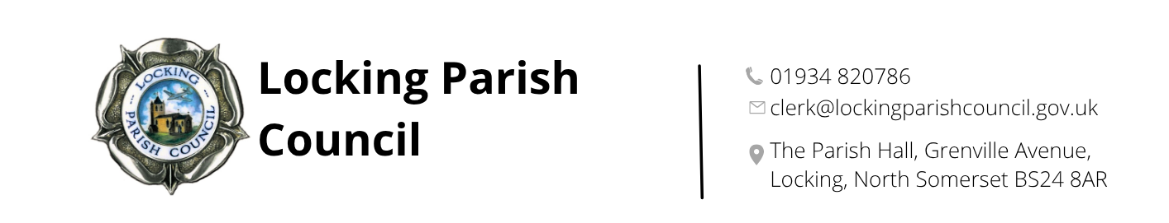

Members of the Public and Press are entitled to be at the following meeting in accordance with the Public Bodies (Admission to Meetings) Act 1960 section 1 extended by Local Government Act 1972 section 100 unless precluded by the Parish Council by resolution during the whole or part of the proceedings. Such entitlement does not however include the right to speak on any matter except at the commencement of the meeting given over specifically for that purpose and providing that prior notice has been given to the Parish Clerk by 12noon on the Tuesday preceding the meeting.

To: All members of Locking Parish Council:

Dear Councillors

You are summoned to a meeting of Locking Parish Council to be held in the Nurse Thomas Suite, Locking Parish Hall, Grenville Avenue, Locking on Thursday 4 June 2026 commencing at 7pm when the following business will be transacted.

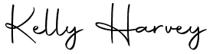
Kelly Harvey
Clerk/RFO
27 May 2026

CO-OPTION MEETING TO COMMENCE AT 7PM

Having regard to the confidential nature of the business to be transacted, the Co-option meeting is now not open to the Press and Public pursuant to Section 1 of the Public Bodies (Admission to Meetings) Act 1960
- Chair to open the Co-option Meeting
- To receive apologies for absence and to approve reasons where appropriate
- Co-option of new councillor(s)
- Signing of Declaration of Office and completion of Register of Members Interest Form
- Chair to close the Co-option meeting

FULL COUNCIL MEETING TO COMMENCE AT 7.30PM

The meeting will be open to the press and members of the public

AGENDA

PUBLIC PARTICIPATION

To receive and hear any person who wishes to address the Council, upon prior notice being received (The Chairman will select the order of the matters to be heard, each speaker will be limited to a period of 3 minutes (to a maximum of 15 minutes total public participation at the Chairman’s discretion).

- Unitary Cllr/Liaison Officer Report
- Police Report

- To receive apologies for absence and to approve reasons where appropriate.

- To receive declarations of interest by councillors and to consider any written applications for dispensations.

- Minutes: To receive and confirm the minutes of the council meeting held on 7 May 2026

- Finances:
  - To retrospectively approve monthly receipts and payments from 1 to 30 April 2026
  - To retrospectively approve monthly receipts and payments from 1 to 31 May 2026
  - To note the bank reconciliation and Unity Trust and Nationwide bank statements for April 2026
  - To review expenditure against budgets for the month of April 2026
  - To review expenditure against budgets for the month of May 2026
  - To consider the opening of trade accounts with WSM Fasteners and B&Q TradePoint/Screwfix

- Chairman’s Report

- Regular Reports - To receive and note the following regular reports:
  - CPRE
  - Locking Parklands Stakeholders

- Planning (applications can be viewed via North Somerset Council Planning Applications website)
NONE RECEIVED
- To review the current arrangements for advertising within the Looking at Locking newsletter
- To consider the legal advice received regarding an allotment wall identified as a potential health and safety issue and to agree appropriate next steps
- Incident report forms

- Clerk’s Report, Correspondence & Items for next Agenda: (Please note that the Council is unable to make any formal decisions under this item). To receive the Clerk’s report, note any correspondence received since the last meeting that is not an item on the agenda and note items for the next Agenda.

PART 2

- To receive interview panel recommendation for appointment of Parish Orderly Assistant.

The next meeting of Locking Parish Council 2 July 2026

Members are reminded that the Council has a general duty to consider the following matters in the exercise of any of its functions:
Equal Opportunities (race, gender, sexual orientation, marital status and any disability) Crime & Disorder, Health & Safety and Human Rights.

