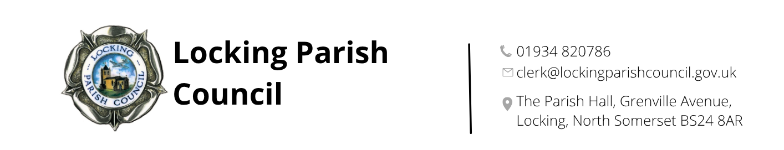
Executive committee
Terms of Reference

Council Standing Order 4 states:
"The Council shall at its Annual Meeting appoint Standing Committees, and may at any other time appoint such other Committees as are necessary, but subject to any statutory provision in that behalf: It shall determine the number of persons to serve on the Standing Committees and shall draw up/review their Terms of Reference."
"There shall be an Executive Committee comprising the Chairman and Vice-Chairman of the Council and the Chairmen of the two major Committees. The Committee shall meet on an ad hoc basis, at the discretion of the Council Chairman, to deal with matters that require an urgent decision and/or for which it would be inappropriate to call a special meeting of the Council."

URGENT BUSINESS
1. To meet, if necessary, without the statutory three clear days' notice, to deal with any matter on which an immediate decision is needed and to issue instructions for immediate action.
2. To report to the Council at the earliest opportunity the action taken, especially to receive confirmation of any expenditure involved.

OTHER BUSINESS
1. To meet, normally with the statutory three clear days' notice, to discuss matters that do not need a special meeting of the Council but require a speedy response e.g. consultation with/requests from other bodies.
2. a) To report to the Council at the earliest opportunity the actions taken,
b) If necessary, to put proposals/recommendations to the Council for decision.

Adopted: 7 May 2026 Full Council meeting, minute reference: 196c

