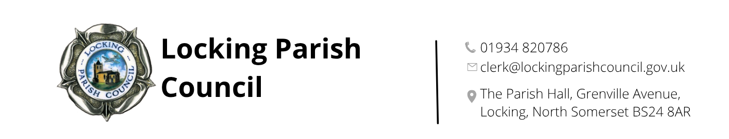

LOCKING PARISH COUNCIL

JOB DESCRIPTION for PARISH ORDERLY

GENERAL

The Parish Orderly shall provide a verbal or written monthly report for meetings of the Assets & Amenities Committee. In between Committee meetings the Parish Orderly shall keep the Clerk informed of any problems for which he / she has responsibility.

SAFETY

At all times the Parish Orderly MUST wear appropriate safety clothing; failure to do this could invalidate the Council’s insurance and may lead to disciplinary procedures. The appropriate safety equipment supplied by the Parish Council must be used and cleaned regularly and maintained in safe working order.

Duties

Pick up and dispose of all litter through Locking village on a daily basis (public holidays excepted) especially round the bus shelters and shop areas. Litter must be disposed of in the waste bin provided by the Parish Council situated in the car park of the Parish Hall.

Maintain the bus shelters in a clean and hygienic condition. The Clerk will supply a list of bus shelters for information.

Ensure that all Public Rights of Way (PROWs) are walkable, clear and tidy. Occasionally, the PO may be called upon to assist in managing overhanging /obstructive vegetation. Initially, any liaison between PO and NSC officers relating to such issues should be via the Clerk. The Clerk will supply a list of footpaths for information.

Plant and maintain the Flower Tubs owned by Locking Parish Council throughout Locking Parish. Authorisation to purchase the necessary plants will need to be given by the relevant committee.

Check fencing and stiles at the Allotments regularly and carry out any necessary minor repairs. Prior authorisation to carry out minor repairs must be obtained from the Clerk.

Alllotment paths – strim and mow on a regular basis.

Maintain the Park and the area surrounding the Parish Hall, to include the side footpath and car parks if necessary, in a clean and tidy condition and free of hazards.

Carry out a daily visual safety inspection of all play equipment, fencing and other safety hazards in the Park and Old Banwell Road Playing Field, and inform the Clerk immediately of any potential H&S problems. The Clerk may then decide whether to `isolate` the faulty piece of equipment and inform the Chair of the Assets & Amenities Committee of his or her action. Should any minor repairs be required, prior authorisation must be obtained from the Clerk.

Complete a monthly safety inspection report form which lists H&S work done during the month, and work that remains outstanding. Outstanding work should be prioritised from low to high. The form should be signed by the PO.
Playing field: Mow and strim around equipment and Community Orchard, Tiny Forest
Pick up and dispose of all litter.
Litter must be disposed of in the waste bin provided by the Parish Council situated in the car park of the Parish Hall.

To assist with watering various flower tubs, trees, Coronation Garden via the water bowser as directed by the Clerk.

To assist with the emptying of the Dog Waste Bins as and when required.

To occasionally carry out handy man services as directed by the Clerk

To attend any training courses required to carry out works required.

