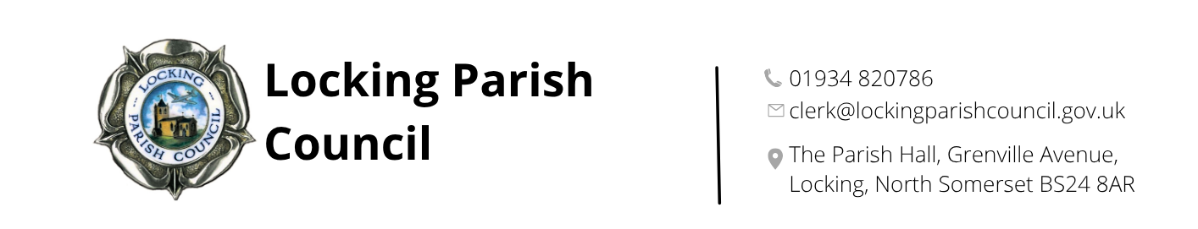

FIRE SAFETY POLICY AND EMERGENCY PLAN

Locking Parish Hall, Grenville Avenue, Locking

This policy will be reviewed annually by Locking Parish Council
Adopted: 5 February 2026
Minute reference: 144) b)

FIRE SAFETY POLICY

Locking Parish Hall is owned and maintained by Locking Parish Council. The Assets & Amenities Committee (A&AC) is responsible for the day-to-day management of the Parish Hall and the implementation of this Fire Safety Policy.

The A&AC will implement the following to ensure the fire safety of all users of the Parish Hall:

FIRE SAFETY LOGBOOKS
All relevant fire safety logbooks including Fire Risk Assessments, alarm tests and firefighting equipment checks will be held and maintained by the Parish Clerk or Clerk’s Assistant and an appointed member of the A&AC.

FIRE ALARM SYSTEM
A fire alarm test will be carried out weekly on at least one call point, with the results recorded in the logbook. The fire alarm system is inspected yearly by a recognised contractor, with the results recorded.

ESCAPE ROUTES & EXITS
All Parish Hall escape routes and fire exits are clearly signed and will be kept free from obstruction at all times, to ensure safe evacuation from the building.

SIGNAGE & ASSEMBLY POINT
Details of escape routes and assembly points should be recorded on the Fire Notices adjacent to manual call points. The emergency plan should be displayed on the notice board in the main hall foyer and the noticeboard in the Nurse Thomas Suite.

EMERGENCY LIGHTING
All emergency lighting will be visually checked at least monthly by the Parish Clerk or Clerk’s Assistant and an appointed member of the A&AC and will be serviced and maintained on an annual basis by a recognised contractor, with the results recorded.

FIREFIGHTING EQUIPMENT
Firefighting equipment will be provided in appropriate places within the Parish Hall, according to the fire risk posed. All firefighting equipment will be visually checked at least monthly by the Parish Clerk or Clerk’s Assistant and an appointed member of the A&AC and will be serviced and maintained on an annual basis by a recognised contractor, with the results recorded. Any extinguisher noticed to have been discharged or damaged must be replaced immediately by the recognised contractor.

ELECTRICAL SYSTEMS & APPLIANCES
The Parish Hall’s electrical wiring installation will be inspected annually by a recognised contractor, and the results recorded.

All portable electrical appliances provided in the Parish Hall will be PAT tested annually by a recognised contractor, with the results recorded.

The gas boiler system will be serviced annually by a recognised contractor, with the results recorded.

FIRE & EMERGENCY EVACUATION
All users of the Parish Hall are required to familiarise themselves with this ‘Fire Safety Policy & Emergency Plan’, which will be sent to all hirers prior to their hire of the hall. A copy of the policy can also be found on the notice board in the main hall foyer and Nurse Thomas Suite.

FIRE SAFETY INSPECTIONS
Regular visual inspections of the Parish Hall and all its fire safety equipment will be conducted by the Parish Clerk or Clerk’s Assistant and an appointed member of the A&AC (monthly) and any concerns should be raised with the A&AC or Full Council at which ever meeting is soonest.

These inspections should ensure, as a minimum, that:
  - All fire routes and exits are free from obstruction.
  - All fire doors are kept shut and not propped open with door stops.
  - All emergency lighting is working.
  - All fire-fighting equipment is present and serviceable and stored correctly.
  - Any flammable liquids are correctly stored.
  - There is no accumulation of rubbish within or near the building to create a fire hazard.
The results of these fire safety inspections should be recorded.

FIRE RISK ASSESSMENTS
A Fire Risk Assessment will be undertaken on an annual basis and the results approved by the A&AC.

The Fire Risk Assessment must be added to the agenda for next available A&AC meeting or Full Council meeting (whichever is soonest), if any changes are made that may potentially impact upon fire safety, such as alterations to the premises or new activities of hirers. To ensure that additional reviews may be undertaken as soon as possible.

FIRE SAFETY GUIDANCE FOR HIRERS

YOU, THE HIRER, are the ‘RESPONSIBLE PERSON’ in the event of a Fire or an Emergency within Locking Parish Hall during your hire of Locking Parish Hall.

At all times the Parish Hall is in use, the RESPONSIBLE PERSON must be in charge, and ready to take control of any incident.

Please read and become familiar with these instructions.

Your priority should always be to Save Lives and not the building!

BEFORE YOUR EVENT STARTS:

- Check that the ‘Fire Exit’ lights are working.
- Check that all escape routes are not blocked, for example, by tables, chairs, or boxes.
- Check that you know where any fire extinguishers or blankets are stored, and the different uses of the water and CO2 fire extinguishers.
- Check that all electrical equipment and extension leads that have been brought into and/or are being used within the Parish Hall look safe to use.
- Check that no balloons or other decorations have been hung where they could fall and obstruct a Fire Exit.
- Inform all your attendees of the Fire Exit routes, and the Assembly Point at the far end of the car park, in the event of a fire or emergency.

DURING YOUR EVENT:

- Know how many people are at your event.
- Keep fire doors closed when not in use, and do not prop them open with door stops.
- Ensure that the Fire Exits and escape routes do not become obstructed.
- Brief any disabled people and/or their assistants regarding their best evacuation route from the Parish Hall in the event of a fire or emergency.
- Ensure that no vehicle obstructs the Parish Hall’s main entrance, so that wheelchair users and those with prams/buggies can exit quickly and safely.
- Ensure that emergency services vehicles have a clear access route to the Parish Hall from the road.
- Ensure that your event attendees do not engage in any activity that is likely to cause a fire, for example, smoking or using candles or other naked flames.
- Be vigilant regarding any smells of burning or a gradual build-up of smoke.

AFTER YOUR EVENT:

- Remove all waste and check rooms for smouldering or items burning.
- Check cookers, heaters and electrical appliances are turned off and unplugged where necessary.
- Turn off lights not required for security purposes and close all internal doors.
- Secure all external doors and windows.

EMERGENCY PLAN

FIRE NOTICE
In the event of a fire

DIAL 999
- The responsible person in charge of the hall will give loud and clear instructions and tell all persons to
  - Leave the building using the nearest available exit
  - Meet at the ASSEMBLY POINT – Basket Swing, Locking Village Park adjacent to Parish Hall

- Start the fire alarm if it is not already sounding, by using a
‘Break Glass Point’ at one of the fire exits.

NO MATTER HOW SMALL THE FIRE, CALL THE FIRE BRIGADE.
There is no public telephone nearby. Use a mobile to call 999.

GIVE THIS ADDRESS:

Locking Parish Hall
Grenville Avenue
Locking
BS24 8AR
Check every room that is safe to enter, to ensure everyone has left. Use firefighting equipment to clear a safe passage to a fire exit.
Check that everyone is accounted for and do not allow anyone to re-enter the building under any circumstances.

On arrival of the Fire Brigade, report to the Officer in Charge that all persons are safe or state the last known location of anyone missing.

All incidents, no matter how small, must be reported.

LOCKING PARISH HALL

FIRE ESCAPE ROUTES & EQUIPMENT LOCATIONS

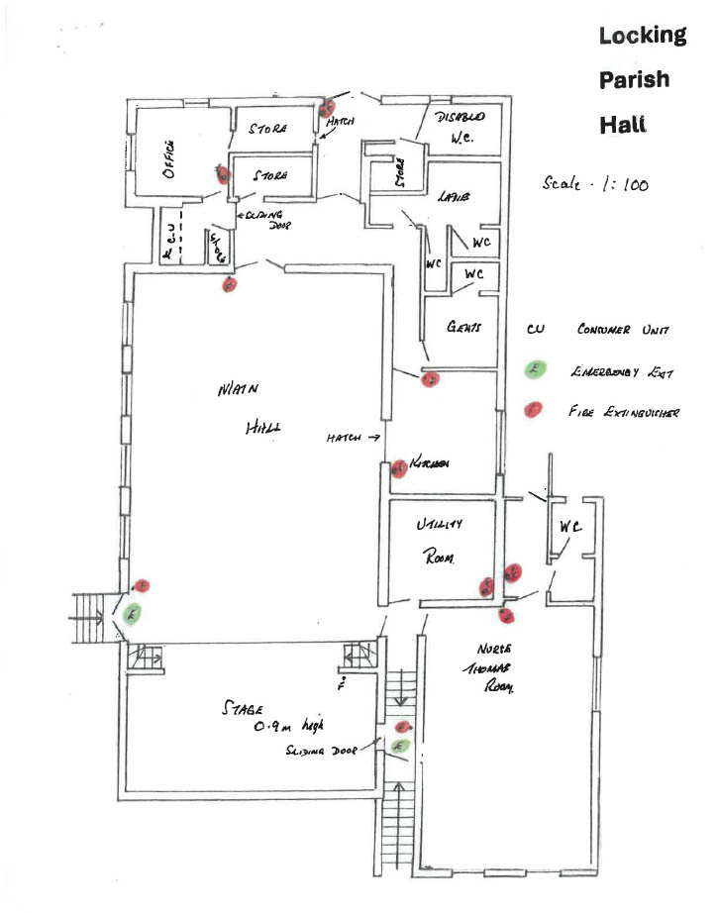

Cleaner’s Cupboard

Emergency exit
Stationery Cupboard
Stage
Fire extinguisher

Nurse Thomas Suite
NTS Kitchen
Gents toilet
Ladies’ toilet
Accessible toilet

Office
Main
kitchen
Main Hall

Contact details for the parish hall and park

1st contact
Parish office: 9am – 3pm
01934 820786
admin@lockingparishcouncil.gov.uk

Any parish hall or park issues outside of 9am to 3pm please contact one of the following

1st contact
Cllr Ian Hilder
07724 996269

2nd contact
LPC Chair - Cllr Paul Jones
07928 680464

