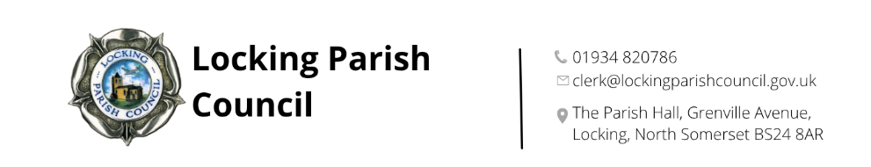

Complaints procedure
This procedure explains how members of the public can raise complaints about the Parish Council’s administration, decisions, or the conduct of its staff. It ensures complaints are handled fairly, consistently, and promptly.
This procedure does not cover:
- Complaints about individual councillors
(this is handled by the Monitoring Officer at North Somerset Council)
- Complaints relating to financial irregularities (this is handled under audit regulations)
- Complaints relating to criminal matters (these are handled by the police)
- Employment-related complaints from staff (these are handled through internal HR procedures)
The appropriate time for influencing Council decision-making is by raising your concerns before the Council debates and votes on a matter. You may do this by writing to the Council in advance of the meeting at which the item is to be discussed. There may also be the opportunity to raise your concerns in the public participation section of Council meetings.
If you are unhappy with a Council decision, you may raise your concerns with the Council, but Standing Orders prevent the Council from re-opening issues for six months from the date of the decision, unless there are exceptional grounds to consider this necessary and the special process set out in the Standing Orders is followed.
Informal Resolution
Many concerns can be resolved quickly and informally.
- Members of the public are encouraged to raise issues with the Clerk in the first instance.
- The Clerk will attempt to resolve the matter promptly, usually within 10 working days.
- If the complaint concerns the Clerk, the matter should be raised with the Chair of the Council.
If the issue cannot be resolved informally, the complainant may submit a formal complaint.

Submitting a Formal Complaint
A formal complaint must be made in writing, by letter or email, to the Clerk (or to the Chair if the complaint concerns the Clerk).
The complaint should include:
- Name and contact details of the complainant
- A clear description of the issue
- Relevant dates, evidence, or correspondence
- What outcome the complainant is seeking
The Council will acknowledge receipt within 5 working days.
Initial Assessment
The Clerk (or Chair) will:
- Review the complaint
- Decide whether it falls within the Council’s remit
- Determine whether it can be resolved without a full investigation
If the complaint is outside the Council’s jurisdiction, the complainant will be directed to the appropriate body.
Investigation
If a full investigation is required:
- The Clerk (or Chair) will gather relevant information, documents, and statements.
- The complainant may be asked for clarification or additional evidence.
- The investigation will normally be completed within 20 working days, or the complainant will be updated if more time is needed.
Hearing by the Council or Committee
If the complaint cannot be resolved by the Clerk or Chair, it will be referred to:
- The Complaints Committee or
- A meeting of the Full Council (excluding any councillors with a conflict of interest)

Decision
After considering the evidence, the Council/Committee will decide:
- Whether the complaint is upheld, partially upheld, or not upheld
- What actions, if any, will be taken
The decision will be communicated in writing within 10 working days of the meeting.
Possible outcomes include an apology, a change in procedure, staff training or no further action.
Record Keeping
The Clerk will keep a confidential record of the complaint, investigation, decision and any actions taken. These records will be retained in accordance with the Council’s data retention policy.
Right of Appeal
If the complainant is dissatisfied with the outcome:
- They may request an appeal within 10 working days of the decision.
- The appeal will be heard by councillors not previously involved.
- The appeal decision will be final.

Adopted: 8 Jan 2026
Minute reference: 129) a)
Review date: January 2027

