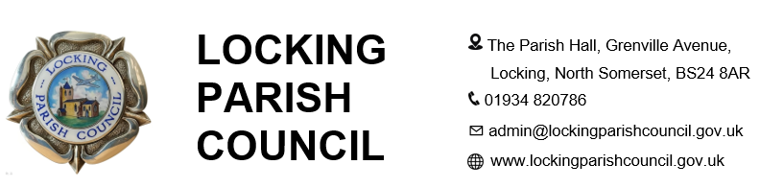
Newsletter Advertising Booking Form 2026

Advertiser Details
Company Name

Address

Contact Name
(Business & Accounts)

Telephone Number

Email Address

Advertisement Options

Advertisement Size | Specification | Price per Issue
Quarter Page | Portrait or Landscape | £28.00
Half Page | Landscape | £49.00
Full Page | A5 Portrait | £125.00

Issue Required: ☐ Spring ☐ Summer ☐ Autumn/Winter

Total Amount Payable: £________________

I confirm that I have read and agree to the Advertising Terms and Conditions.

Signature: _____________________________________________ Date: _______________

Print Name: ___________________________________________

Advertising Information
The Locking Newsletter is an A5 publication delivered to approximately 1,800 households within Locking Parish. The newsletter is also published on Locking Parish Council's website and Facebook page.

Terms and Conditions

1. General Conditions
- Advertisements are accepted subject to available space and approval by Locking Parish Council.
- Locking Parish Council reserves the right to refuse, suspend, amend, remove or decline any advertisement it considers inappropriate, misleading, offensive, discriminatory, defamatory, political or otherwise unsuitable.
- Acceptance or publication of an advertisement does not constitute endorsement, recommendation or approval by Locking Parish Council.

2. Advertising Standards and Content
- Advertisements must comply with all applicable laws, regulations, Advertising Standards Authority requirements and recognised advertising standards.
- Advertisements must accurately describe the products or services promoted.
- Advertisers are responsible for ensuring all information contained within an advertisement remains accurate and up to date.
- Evidence supporting advertising claims must be supplied upon request.
- Advertising content shall have no influence over editorial content and must be clearly distinguishable from Council communications.

3. Political Neutrality
- Advertisements from political parties, election candidates, campaigning organisations or organisations whose objectives conflict with the Council’s statutory duties may not be accepted.
- Locking Parish Council reserves the right to reject any advertisement that may compromise its duty to remain politically impartial.

4. Artwork and Intellectual Property
- Advertisers must hold all necessary intellectual property rights, licences and permissions relating to advertisement content.
- The advertiser warrants that all content supplied may be legally published and does not infringe the rights of any third party.
- Advertisers shall indemnify and hold harmless Locking Parish Council against claims arising from advertisement content.

5. Publication and Distribution
- Advertisements may appear in printed publications, on the Council website, Facebook page and other Council-controlled digital media.
- Placement within the newsletter cannot be guaranteed unless expressly agreed in writing.
- The Council reserves the right to amend publication formats, distribution methods or publication schedules without liability.

6. Payment
- Payment is by BACS. Payment deadlines and bank details will be provided on the invoice.
- Outstanding debts may result in advertisement withdrawal and debt recovery action.
- The Council reserves the right to decline future bookings from advertisers with outstanding invoices.

7. Cancellations and Errors
- Late cancellations may remain chargeable in full.
- The Council will not be liable for losses resulting from errors, delays or non-publication except where required by law.
- Where an advertisement is omitted due to Council error, the Council may offer either a refund or a replacement advertisement in a future edition.

8. Limitation of Liability
- Locking Parish Council’s total liability in relation to any advertisement shall not exceed the amount paid by the advertiser for the advertisement concerned.
- The Council shall not be liable for any indirect, consequential or business losses arising from publication or non-publication of an advertisement.

9. Data Protection
- Personal information provided by advertisers will be processed in accordance with UK GDPR, the Data Protection Act 2018 and the Council’s Privacy Notice.
- The Council Privacy Notice is available at www.lockingparishcouncil.gov.uk.

