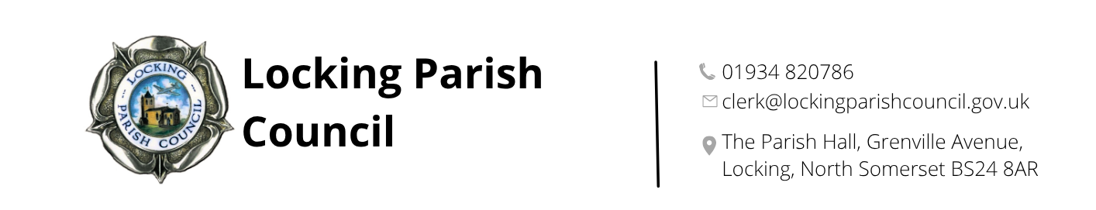

9 December 2025

Dear Applicant

Vacancy: Clerk’s Assistant

Thank you for expressing an interest in the above position. Please find attached:

- Job description and person specification
- Application form

At Locking Parish Council, we firmly believe in the power of community engagement and collaboration to create positive change. We are a forward-thinking council, always seeking new and innovative ways to improve the lives of our residents and the overall well-being of our community.

We are looking for someone who is highly organised, with excellent communications skills and the ability to work independently and as part of a team.

The successful candidate will have the opportunity to make a real impact in the community, working alongside Councillors helping to shape the future of Locking Parish.

Please note that this is a Locking based position and a requirement of the post is that the successful candidate will be required to carry out occasional evening work to service the Council and its Committees.

If you feel this could be you and wish to be considered for the post, please complete the attached application form and return admin@lockingparishcouncil.gov.uk.

Information may be copied and stored on a database and used during the recruitment process or used to form part of the personnel files if successful.

The deadline for applications is 12 January 2026. Shortlisting and interviews will take place during January with an anticipated start date of Monday 2nd March 2026.

Yours sincerely,

Dawn Tremlett
Clerk/RFO

